Intermediate Algebra Lecture 12.2: An Introduction to Inverse Functions
One-to-one
Each input has a unique output.
For points on a line the x value is the input, the y value is the output.
For each x must have a unique y,

Example

Below graphs pass the Vertical line test all are functions ( is a function if the line has unique x values)
Below graphs maybe 1 to 1 functions if the pass the horizontal line test (1 to 1 functions if the line has unique y values)

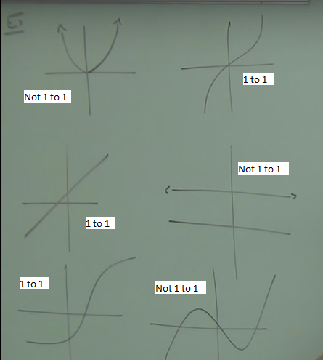

Inverse functions
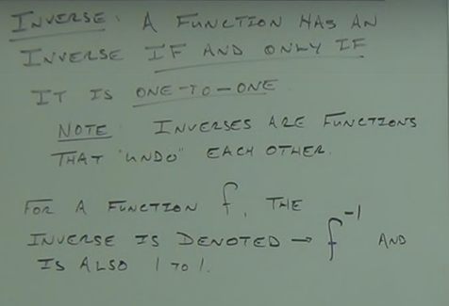

Example
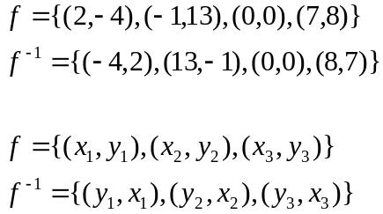

To find an inverse, switch x & y
(This undoes what was done)

Steps to create an inverse function
- write function as y=
- Switch x and y
- Solve for y
- Replace y with f inverse notation

Example

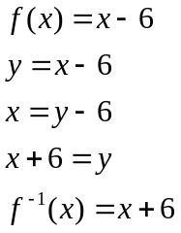

Example
Find the inverse function

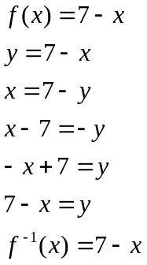

Example
Find the inverse function

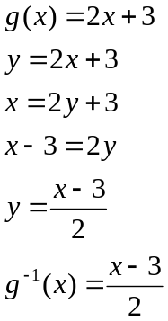

Example
Find the inverse function

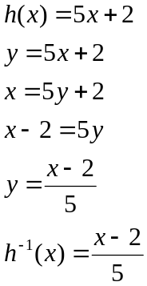
Example
Find the inverse function

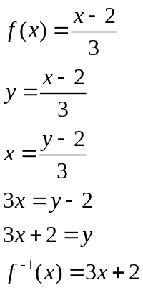

Inverse functions mirrors the the graph on y=x line

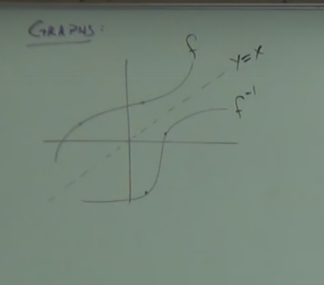

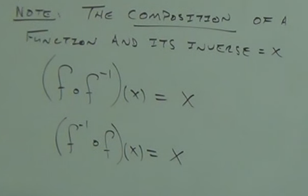

Example
